TechLife Daily

11 July 2024
Neural link: A new step towards future

I
n an announcement Elon
Musk's ‘Neuralink’s techs unveiled latest innovation, a braincomputer-intrface chip designed to revolution-ize the way humans to interact with a modern tech-nology. This new ambitious project, which has been in develop- ment for years, promises to bridge the big gap between human minds and machines, opening up a plethora of possibilities in the realms of healthcare, communication, and beyond.

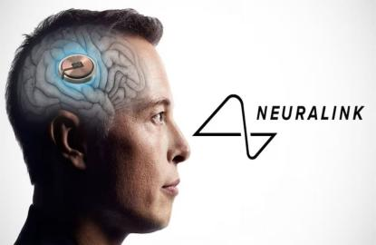

What is Neuralink's Brain Chip?
Neuralink's new brain chip, often referred as the "Link," is a quite small, implantable device that’s designed to be placed directly inside the humanbrain. The device has a new network of ultra-thin electrodes that are capable of quickly monitoring and controling our brain activity. The very primary goal is to enable direct data and info contact between the brain and the connected modern devices, essentially creating a quite seamless interfaces

between the normal humans and computers.
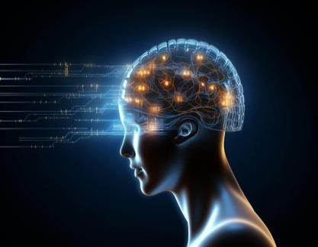
Potential Applications and Benefits
Medical’s Breakthroughs: One of the most promising applications of Neuralink's brain chip is in the field of medicine. The n-technology has the potentials to offer new effective treatments for neurological disorders such as the Parkinson's disease, epilepsys, and spinal cords injuries by providing a very direct interface to the brain, the chip could help restore lost the sensory and motor function,that’ll significantly improving the quality of life for patients.
Enhanced Communication:The chip could also get revolutionize communications, especially for individuals with severe disabilities. Those who are unable to speak or move-due to conditions like ALS (amyotrophic-lateral scleros) could use the brain chip for communication or contacts

directly through the text or speech synthesizer,by using only their thoughts.
Cognitive Enhancements: Beyond the usual medical applications, the Neuralink envisions a future where the brain chip could be used for cognitive data enhancement. This includes the possibility of improving our memory, learning abilities, and even providing direct access to digital information without the need for the traditional input devices.

Ethical Talk and Privacy Concerns:
While there are the massive potential of benefits are vast, the introduction of such an trans-formative technology can also raise the significant ethical and privacy concern. Critics argue that the ability to read and also potentially manipulatin thoughts could lead to issues of consent, autonomy, and data security. Ensuring that the very new technology is always used responsibly and that robust safeguards are in place will be crucial as the Neuralink moves forward.

The Road Ahead
Neuralink has already begun conducting trials on the animals, and the human trials are anticipated in the near future. These trials will be essential in proving the safety and efficacy of the technology. As with any pioneering innovation, there are bound to be challenges and setbacks, but the potential reward make this an endeavor that’s worth it
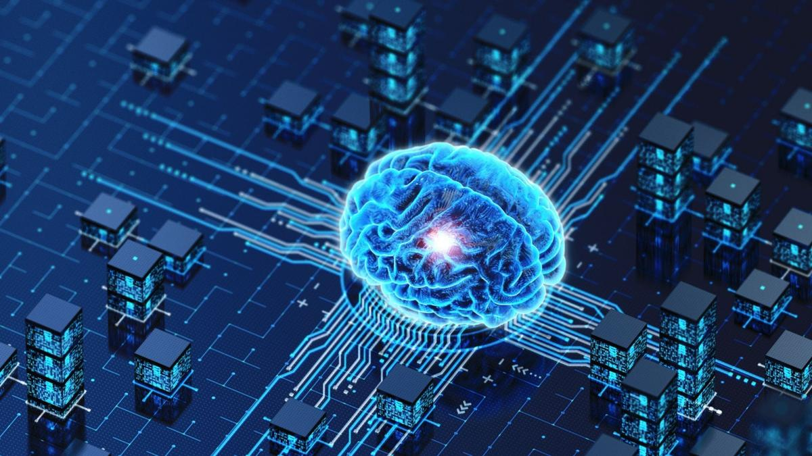
Elon Musk's ambitious vision of a new symbiotic relationship between humans and artificial intelligence is now closer than ever to becoming a reality. The recent unveiling of Neuralink's groundbreaking brain chip marks a significant milestone in this journey. The world watches with bated breath as we step into a future where the boundaries between man and machine continue to blur. This innovative technology has the potential to revolutionize the way we interact with the new digital world, merging our biological capabilities with artificial enhancements. As

we look forward to this transformative future, we can only hope for the best and embrace what’s to come. The rapid pace of new discoveries will undoubtedly challenge our adaptability, but as time passes, we will gradually acclimate to these changes. The introduction Neuralink brain chip represents more technologically integrated future that’s

in a very new and far better era of humans development. However, while the prospects are exciting, they also come with their share of uncertainties. The potential for chaos and unforeseen consequences cannot be ignored. Therefore, it is imperative that scientists and researchers take all necessary precautions to mitigate the risks and ensure the better safe implementation of this new technology. The balance between innovation and safety will be crucial to this uncharted territory, and only time will reveal the true full impact of Neuralink’s advancements.

